**Flask To-Do Project Git Workflow Submission**

**GitHub Repository:** <https://github.com/Pooja332211/flask-todo-project>

**1. SSH Key Setup**

**Command:**

ssh-keygen -t ed25519 -C "poojasattigeri83@gmail.com"

cat ~/.ssh/id_ed25519.pub

**Screenshot:**  
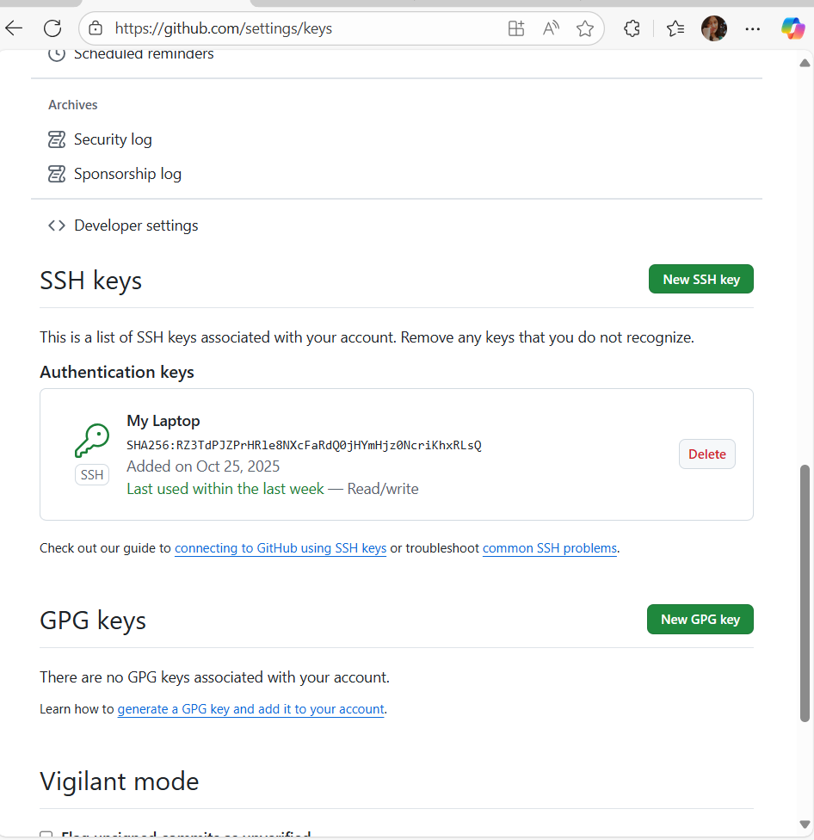

**2. Clone Repository & Configure Git**

**Commands:**

git clone git@github.com:Pooja332211/flask-todo-project.git

cd flask-todo-project

git config --global user.name "Pooja Sattigeri"

git config --global user.email "poojasattigeri83@gmail.com"

**Screenshot:**  
*(Insert screenshot showing repository cloned and git config set)*

**3. Create Branch and Add Initial Files**

**Commands:**

git checkout -b pooja

git add .

git commit -m "Add initial Flask project files"

git push -u origin pooja

**Screenshot:**  
*(Insert screenshot showing branch created, commit, and pushed)*

**Merge into main:**

git branch -m main

git push -u origin main

**Screenshot:**  
*(Insert screenshot showing main branch pushed to GitHub)*

**4. Update JSON in a New Branch**

**Commands:**

git checkout -b pooja_new

# Update data.json

git add data.json

git commit -m "Update JSON for /api route"

git push -u origin pooja_new

git checkout main

git merge pooja_new -m "Merge updated JSON from pooja_new branch"

git push origin main

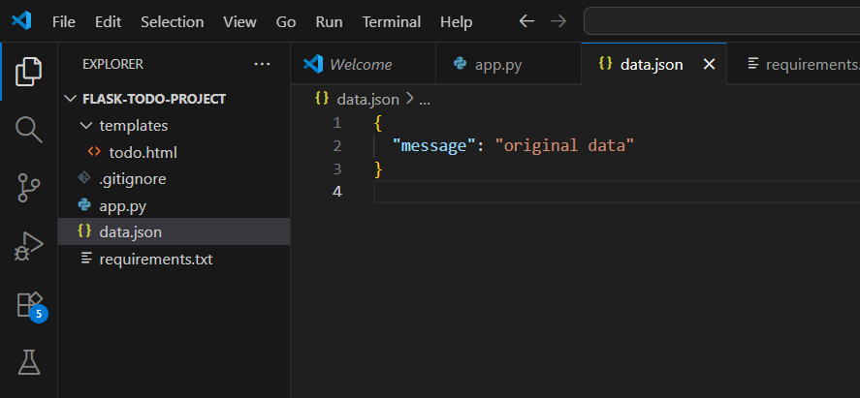

**5. Feature Branches (Frontend & Backend)**

**Create Feature Branches**

git checkout -b master_1

# Add To-Do page frontend

git add templates/todo.html app.py

git commit -m "Add To-Do page frontend with form"

git push -u origin master_1

git checkout main

git checkout -b master_2

# Add backend route /submittodoitem in app.py

git add app.py

git commit -m "Add /submittodoitem backend route"

git push -u origin master_2

**Merge Feature Branches**

git checkout main

git merge master_1 -m "Merge To-Do frontend from master_1"

git merge master_2 -m "Merge /submittodoitem backend from master_2"

git push origin main

**Screenshot:**  
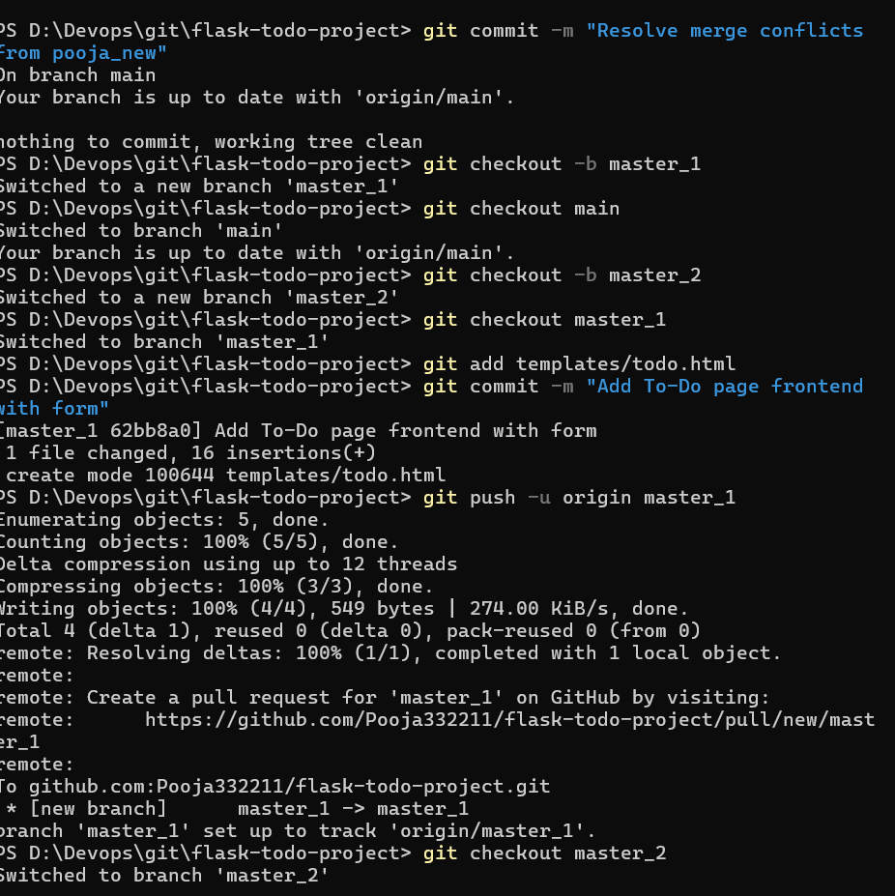

**6. Enhance To-Do Form in master_1**

**Commands:**

git checkout master_1

# Add fields separately

git add templates/todo.html app.py

git commit -m "Add Item ID field"

git add templates/todo.html app.py

git commit -m "Add Item UUID field"

git add templates/todo.html app.py

git commit -m "Add Item Hash field"

git push origin master_1

git checkout main

git merge master_1 -m "Merge enhanced To-Do form from master_1"

git push origin main

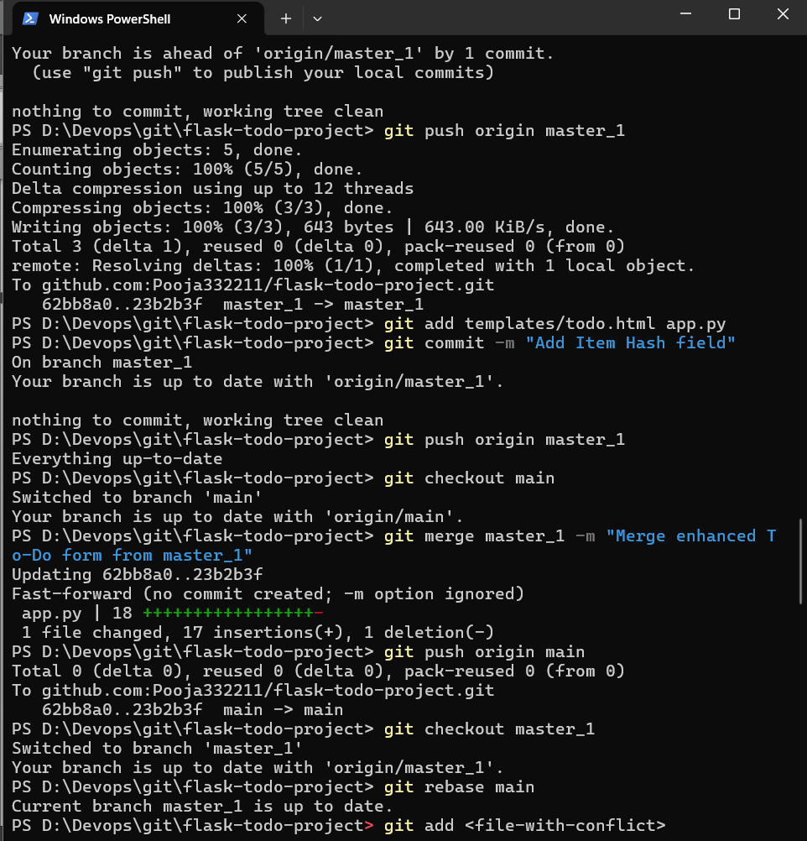

**7. Git Reset & Rebase**

**Reset main to only Item ID field:**

git log --oneline # find commit hash of "Add Item ID field"

git reset --soft <commit-hash>

git commit -m "Recommit only Item ID field"

git push --force origin main

**Rebase master_1 onto main:**

git checkout master_1

git rebase main

git push --force origin master_1

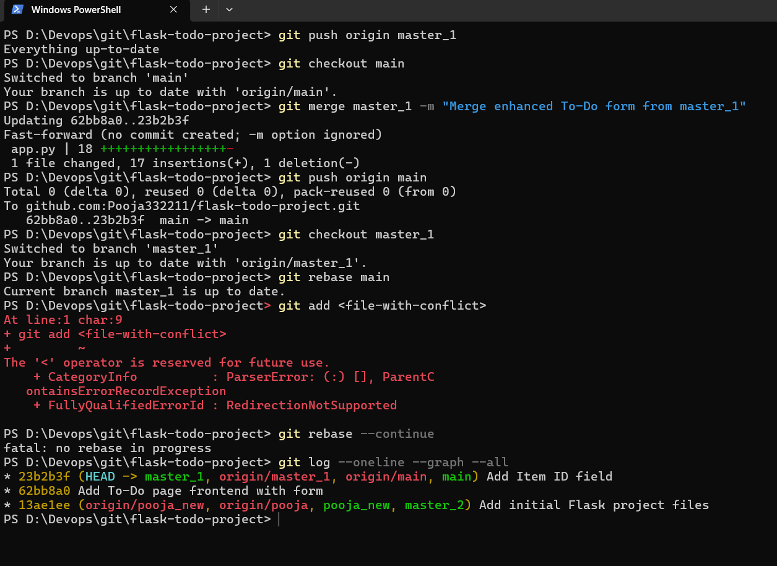

**8. Verify Branches & Commit History**

**Commands:**

git log --oneline --graph --all

git branch -a



